

Mini Project Report

of

Database Systems Lab (CSE 2262)

Library Management System

SUBMITTED

BY

Dev Vasudevan - 220962378 Roll no. 60

Reeva Nanda- 220962310 Roll no. 48

Department of Computer Science and Engineering

**Manipal Institute of Technology, Manipal.**

**April 2024**



DEPARTMENT OF COMPUTER SCIENCE & ENGINEERING

Manipal

00/00/2024

CERTIFICATE

This is to certify that the project titled MiniProject Title is a record of the bonafide work done by Dev Vasudevan (220962378), Reeva Nanda (220962310) submitted in partial fulfilment of the requirements for the award of the Degree of Bachelor of Technology (B.Tech.) in COMPUTER SCIENCE & ENGINEERING of Manipal Institute of Technology, Manipal, Karnataka, (A Constituent Institute of Manipal Academy of Higher Education), during the academic year 2023-2024.

Name and Signature of Examiners:

1. Dr. Anup Bhat B, Assistant Professor, Dept. of CSE
2. Dr. Vijaya Arjunan, Additional Professor, Dept. of CSE
3. Dr. T Sujithra, Associate Professor, Dept. of CSE (A2 Batch)

3. Dr. Shwetha Rai, Assistant Professor-Senior Scale, Dept. of CSE (A1 Batch)

TABLE OF CONTENTS

ABSTRACT

**CHAPTER 1: INTRODUCTION**

**CHAPTER 2: PROBLEM STATEMENT & OBJECTIVES**

**CHAPTER 3: METHODOLOGY**

**CHAPTER 4: RESULTS & SNAPSHOTS**

**CHAPTER 5: CONCLUSION**

**CHATER 6: LIMITATIONS & FUTURE WORK**

**CHAPTER 7: REFERENCES**

CHAPTER 1: INTRODUCTION

The Library Management System aims to streamline and enhance the management of a library’s resources and services.

It is designed to replace traditional paper based methods with a comprehensive database system , ensuring accuracy ,efficiency and speed.

Using Oracle SQL we have created a database system for a library that stores relevant information and carries out relevant procedures and we have linked it to a python user interface .

CHAPTER 2: PROBLEM STATEMENT & OBJECTIVES

**2.1 Problem Statement**

The traditional methods of managing library operations have long been characterized by manual processes and inefficient record-keeping systems. Such an approach often results in limitations that hinder the smooth functioning of library services. The identified challenges that we want to fix with a database system include:

* Manual Cataloging and Inventory Management: The absence of a centralized database system leads to manual cataloging and inventory management, which is time-consuming and prone to errors. As a result, maintaining an accurate record of available resources and their status becomes a daunting task.
* Inefficient Borrowing and Return Processes: The manual handling of borrowing and return processes is prone to delays and inconsistencies. Library staff often struggle to track borrowed items, leading to difficulties in managing overdue materials and enforcing borrowing policies effectively.
* Subscription and Dues Management: It can be difficult to track payment statuses and enforce subscription privileges consistently if the work is done manually .With the help of a database system , we can keep track of the subscription of each user and can therefore keep track of all finances safely

In light of these challenges, we have implemented a library management system that leverages database technologies to streamline operations, enhance accessibility, and improve overall efficiency.

**2.2 Objectives**

The primary objectives of the proposed library management system project are as follows:

* Cataloging and Inventory Management: Implement a centralized database system to automate the cataloging and inventory management processes, ensuring accurate and up-to-date records of library resources.
* Enhanced Accessibility and Visibility: Develop user-friendly interfaces that provide the library staff with real-time access to information about resource availability, thereby promoting the optimal utilization of library materials.
* Streamlined Borrowing and Return Processes: Design and implement streamlined workflows for borrowing and return processes, enabling efficient tracking of borrowed items, tracking of overdue materials, and seamless enforcement of borrowing policies.
* Integration of Subscription and Dues Management: Integrate subscription and dues management functionalities into the system to facilitate seamless tracking of user subscriptions, timely invoicing of dues, and enforcement of subscription privileges.

CHAPTER 3: METHODOLOGY

3.1 ER Diagram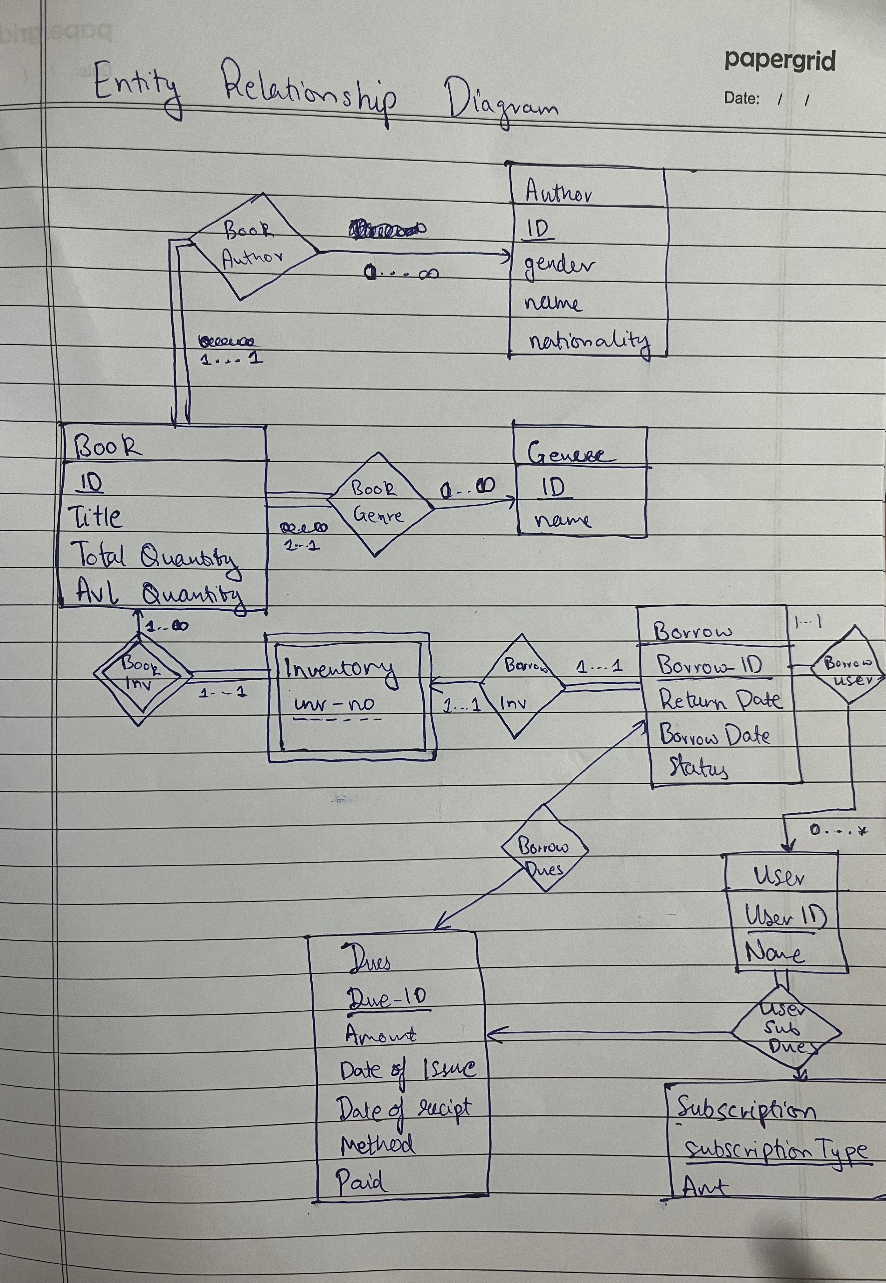

3.2 Schema Conversion

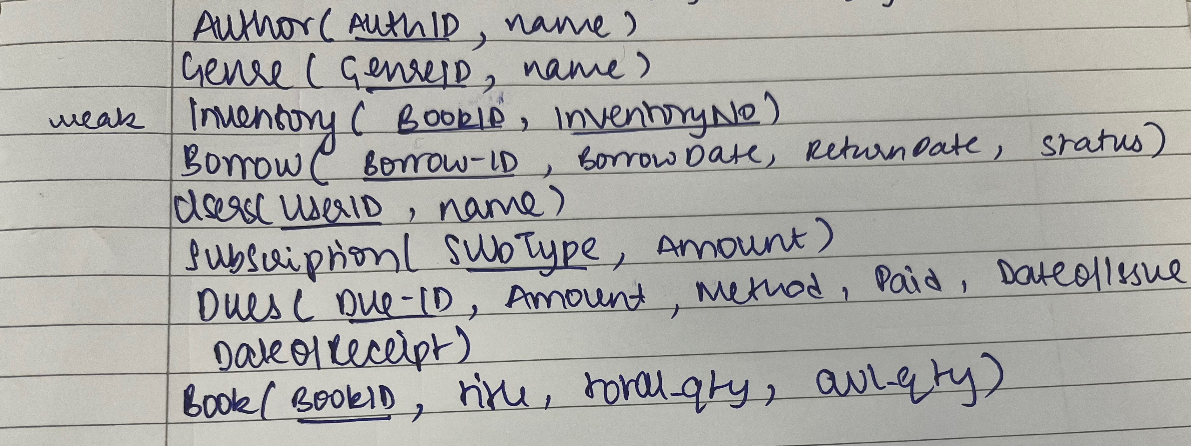Step1: Schema for Strong and weak entities

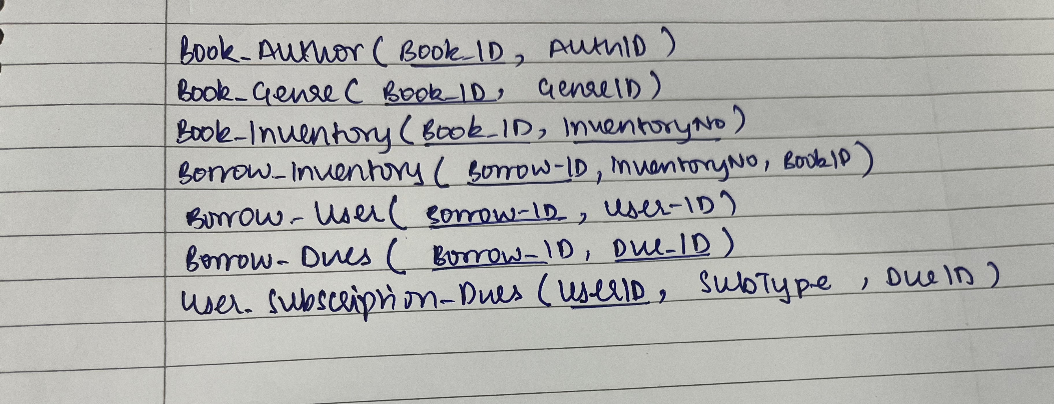**Step 2: Schema for Relationship Sets**

**Step 3:Removing Redundant Schema**

Remove book_inventory because it has the same schema as inventory .

**Step 4:Merging the Schemas**

* Book_Author and Book_Genre get merged into Book   
  - Book (BookID, AuthID, GenreID, Title, TotalQty, AvailableQty)
* Borrow_Inventory and Borrow_User get merged into Borrow  
  -Borrow (BorrowID, BorrowDate, ReturnDate, Status, InventoryID, BookID, UserID)

Step 5: Identify Functional Dependencies

* Book: {BookID} -> {AuthID, GenreID, Title, TotalQty, AvailableQty}
* Author: {AuthID} -> {Name}
* Genre: {GenreID} -> {GenreName}
* Inventory: {BookID, InventoryNo} -> {}
* User: {UserID} -> {SubscriptionType, Name}
* Borrow: {BorrowID} -> {BorrowDate, ReturnDate, Status, InventoryID, BookID, UserID}
* Dues: {DueID} -> {Amount, Method, Paid, DateOfIssue, DateOfReceipt}
* Subscription: {SubType} -> {Amount}
* UserSubscriptionDues: {UserID, SubType} -> {DueID}
* Borrow_Dues: {BorrowID} -> {DuesID}

In each table, every determinant is non-trivial and forms a super key, thus satisfying the requirements for BCNF.

**Step 6: Final Schema**

* Book (BookID, AuthID, GenreID, Title, TotalQty, AvailableQty)
* Author(AuthID, Name, Nationality, Gender)
* Genre(GenreID, GenreName)
* Inventory(BookID, InventoryNo)
* Users (UserID, SubscriptionType, Name)
* Borrow (BorrowID, BorrowDate, ReturnDate, Status, InventoryID, BookID, UserID)
* Dues (DueID, Amount, Method, Paid, DateOfIssue, DateOfReceipt)
* Subscription (SubType, Amount)
* UserSubscriptionDues (UserID, SubType, DueID)
* Borrow_Dues(BorrowID, DuesID)

3.3 PL/SQL

Using PL/SQL we have created procedures and triggers to carry out all the functionalities required .

1. Add Author : The add_author procedure will add an author to the author table .
2. Add Genre: The add_genre procedure will add a genre to the genre table .
3. Add Book : The add_book procedure will add a book to the book table . If the book is already present in the library then the available quantity and total quantity of the book is increased and a tuple is inserted into the inventory table . If the book is not present in the library then a new tuple is inserted into the book and inventory table and both Add Author and Add Genre procedures are called if author or genre do not exist .
4. Add User: Adds a user to the users table. It then proceeds to offer the user 1 out of 3 lifetime subscriptions (Platinum, Gold, Silver) which allows users to borrow books for longer periods of time
5. Trigger user_subscription_dues : Every time a user is added, this trigger adds a tuple in the user_subscription_dues table to keep track of all the payments received by the library when a user buys a subscription
6. Borrow Book : Changes the availability status of the book being borrowed in inventory table, decrements the available quantity in the book table, inserts a tuple into the borrow table and sets the expected return date based on the type of subscription purchased by the user
7. Return Book: Changes the availability status of the book received in inventory table and increments the available quantity in the book table . If the user returns the book late then the user is fined and a tuple is inserted into the borrow_dues table.
8. Money_received : This function is called in 2 places , once when a user is being fined for late returns and another when the user is buying a subscription. This function accurately makes updates to all necessary tables every time the library receives money .
9. Display various aspects of the libraries crucial data

CHAPTER 4: RESULTS AND SNAPSHOTS

DDL COMMANDS

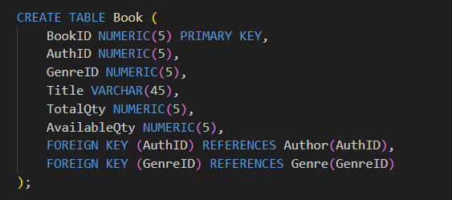

Creating one of the procedures and Triggers

Running the Program using a Menu Driven UI

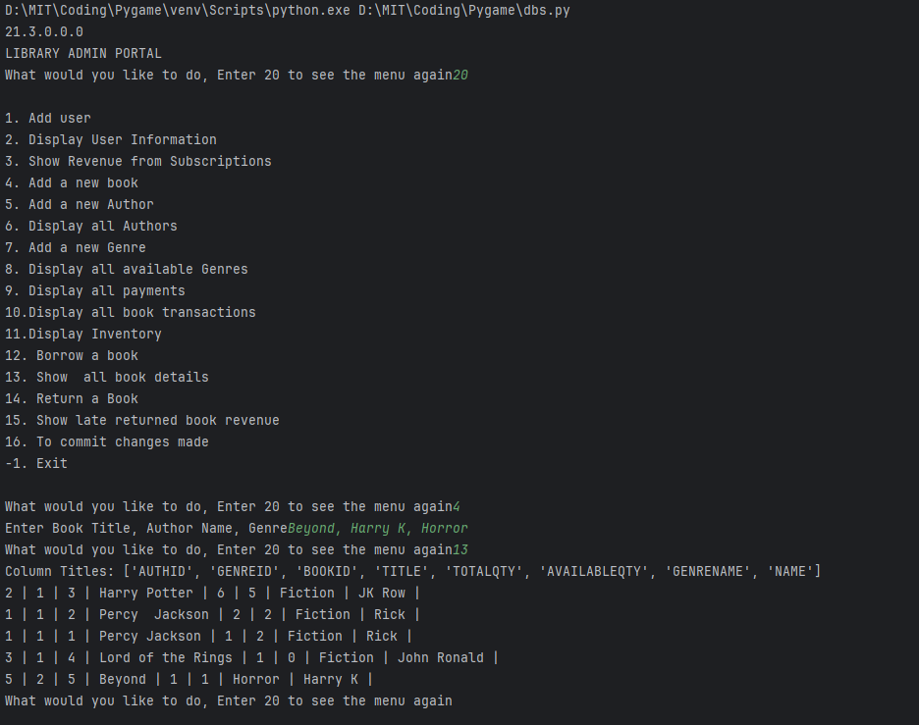

CHAPTER 5 : CONCLUSION

With the help of the ER diagram we managed to derive a schema that allowed us to create a well functioning database system with a normalized schema.  
Using PL/SQL all functionalities were carried out seamlessly .   
In conclusion, this project has successfully addressed the need for an efficient and user-friendly library management system through the implementation of a comprehensive database system by leveraging modern technologies and adhering to best practices in database design.

CHAPTER 6 : LIMITATIONS AND FUTURE WORK

Limitations:

* Currently our library management system is only to be used by library staff.
* Not alerting staff when users’ book’s due date is about to pass
* No easy way to renew a book

Future Work:

* We could add user modes to allow users to access library resources without having to interact with library staff all together
* Allowing upgradation of Subscription
* Creating option for monthly subscription
* Allowing users to Pre-Book a book that is currently unavailable and enter into logical queues to aquire said book
* Extend work for magazines and other domains